LOVELY PROFESSIONAL UNIVERSITY
PHAGWARA, PUNJAB
Department of School of Computer Science
PROJECT REPORT
RAINFALL ATLAS: NATURAL RAINFALL REGIME DISCOVERY FROM HISTORICAL PATTERNS
A 3D Climate Intelligence Platform
Submitted by
Sagar khandai
Registration Number: 12508282
In partial fulfillment for the requirements of the award of the degree of
B.Tech.CSE
School of Electronics & Communication Engineering
Under the Guidance of
Hitesh Jangid
Submission information | Details
Problem Statement ID | CSE327 / Climate Data Science
Group members | Sagar Khandai
Programme / Institution | B.Tech. CSE
Submission date | November 3, 2026
GitHub Repository Link | https://github.com/Sagarkhandai/rainfall-regime-discovery/tree/main
Live Deployed Project Link | https://rainfall-atlas-ca-eo9s.onrender.com/

Executive Summary
The Rainfall Atlas is a full-stack analytical platform designed to explore historical Australian weather observations and uncover latent meteorological patterns using unsupervised machine learning. By synthesizing data preprocessing, partition-based clustering (K-Means), Manhattan-distance medoid partitioning, agglomerative hierarchical clustering, internal metric validation, Principal Component Analysis (PCA), and empirical cluster profiling, the application provides comprehensive spatial and temporal insights into continental climate regimes.
The dataset contains 145,460 daily observations and 23 raw variables across 49 distinct Australian locations spanning November 1, 2007, to June 25, 2017. The primary feature space utilizes 11 continuous meteorological attributes. Target variables (RainToday and RainTomorrow) are excluded from the clustering matrix to prevent data leakage. Robust median imputation handles missingness, a log1p transformation adjusts for precipitation skewness, and feature standardization is applied via StandardScaler.
Model evaluation across K = 2 through 8 reveals that K = 2 yields the global mathematical optimum, achieving the highest Silhouette Score (0.2382) and lowest Davies–Bouldin Index (1.5388). However, K = 4 serves as the exploratory operational baseline due to its granular domain interpretability. Stability testing across five distinct random seeds for K = 4 demonstrates robust partition consistency with a mean Adjusted Rand Index (ARI) of 0.9824.
Comparative analyses incorporate Manhattan-distance medoid partitioning alongside five agglomerative hierarchical configurations (Ward, Complete, and Average linkage). Sampled hierarchical tree structures are evaluated for cophenetic alignment. All generated clusters serve as exploratory synoptic groupings and are not intended for predictive weather forecasting.

Submission Readiness Note
This report reflects the complete analytical codebase and test runs. Live application access is available at https://rainfall-atlas-ca-eo9s.onrender.com/. Administrative placeholders in the metadata block must be finalized prior to final repository submission.

1. Introduction & Problem Statement
Meteorological records encompass highly complex, non-linear interactions across precipitation, temperature, atmospheric pressure, humidity, and wind dynamics. Uncovering latent structures within large-scale multi-variate observations requires automated, objective partitioning methods. This project evaluates whether unsupervised machine learning can discover natural rainfall regimes from historical observations without relying on predefined meteorological classifications.

Problem Statement
Given daily multi-station weather observations across Australia, the goal is to formulate, partition, and interpret multivariate synoptic states. The investigation evaluates partition-based and hierarchical clustering algorithms, validates cluster quality through internal diagnostic indices, and projects high-dimensional weather patterns using Principal Component Analysis (PCA) and 3D web-based visualizations.

Project Objectives
- Load and validate the Rain in Australia weatherAUS.csv dataset and summarize its coverage and quality.
- Select climate-related numerical features and document leakage, missing-value, transformation, and scaling decisions.
- Apply K-Means for multiple cluster counts and evaluate WCSS, Silhouette Score, and Davies-Bouldin Index.
- Compare Euclidean partitioning with a Manhattan-distance medoid-based method.
- Apply agglomerative hierarchical clustering using Ward, Complete, and Average linkage configurations and generate dendrogram data.
- Assess initialization stability and compare cluster assignments with label-invariant measures such as ARI and NMI.
- Use PCA, empirical cluster profiles, and spatial/temporal summaries to interpret the output.
- Expose the analysis through a local web application and FastAPI endpoints.

Scope & Intended Application
The system provides an automated analytical workflow to facilitate climate data exploration, educational demonstrations of unsupervised learning, and preliminary weather-state stratification. It is intended strictly as an exploratory intelligence platform rather than an operational meteorological warning or forecasting model.

2. System Architecture & Workflow
Rainfall Atlas is built on a modular web architecture powered by a high-performance FastAPI backend and a dynamic Three.js / HTML5 interactive frontend. Upon initialization, the backend loads the raw data, executes preprocessing transformation pipelines, warms an in-memory cache of baseline models, and serves analytical outputs via RESTful endpoints.
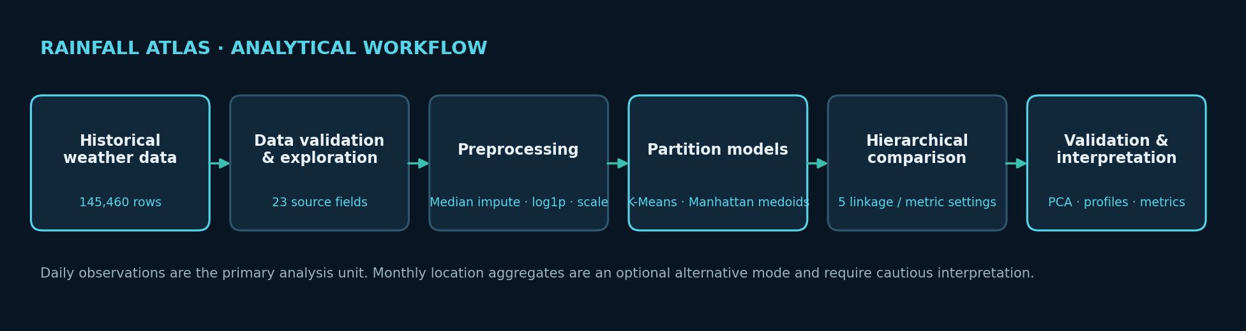
Figure 2. Analytical workflow from historical data to interpretation.

Key Application Features
- Dataset overview and quality summaries, including missingness and rainfall distribution.
- Preprocessing configuration with selected features, imputation, rainfall transformation, and observation-unit options.
- K-Means model runs and K-range evaluation, including WCSS, Silhouette, Davies-Bouldin, and cluster-size summaries.
- Manhattan-distance medoid-based partition comparison and agglomerative hierarchical clustering.
- PCA projection and feature-loading outputs.
- Cluster profiles, location-level distributions, and monthly/seasonal/yearly summaries.
- An experiment registry persisted in JSON and CSV formats.
- A 3D visualization suite for an atmospheric globe, station field, particle clustering concept, hierarchical tree concept, PCA space, and Australia terrain.

Operational Workflow Sequence
- The backend reads weatherAUS.csv and validates required columns.
- The primary daily pipeline selects 11 numerical variables, applies median imputation, transforms rainfall with log1p, and standardizes the features.
- The baseline models are fitted and evaluation outputs are cached.
- The API exposes model metrics, cluster profiles, PCA points, dendrogram structures, geographic distributions, temporal summaries, and experiment records.
- The frontend requests the API data and presents results alongside illustrative 3D explanatory scenes.

3. Dataset Description & Data Quality
The underlying dataset (weatherAUS.csv) comprises daily climate metrics compiled by the Australian Bureau of Meteorology. Observations reflect varied recording equipment and operational schedules across station networks, introducing inherent spatial and feature-level missingness pattern [1, 2].
Dataset attribute | Observed value
CSV observations | 145,460
Source columns | 23
Unique Location values | 49
Date range | 2007-11-01 to 2017-06-25
Duplicate Date–Location pairs | 0
Loaded columns in application | 24 (includes generated observation_id)

Selected Primary Features
Feature group | Variables used
Temperature | MinTemp, MaxTemp, Temp9am, Temp3pm
Rainfall | Rainfall
Humidity | Humidity9am, Humidity3pm
Pressure | Pressure9am, Pressure3pm
Wind speed | WindSpeed9am, WindSpeed3pm

The primary clustering space comprises 11 continuous variables spanning thermal, moisture, pressure, and wind conditions. Categorical flags (RainToday, RainTomorrow) are omitted to avoid artificial distance distortion. Geographic labels are preserved exclusively for downstream spatial indexing.

Data Quality & Missingness Profiling
Quality measure | Observed result
Rainfall missing values | 3,261 (2.24% of rows)
Rainfall zero share among non-missing values | 64.05%
Rainfall skewness | 9.8362
Observations per location | 1,578 to 3,436
Duplicate Date–Location records | 0

Missingness is non-uniform across features: pressure readings (Pressure9am, Pressure3pm) exhibit missing rates near 10.3%, whereas temperature fields demonstrate minimal missingness (<1%). Imputation strategies must account for these variations to avoid distorting density boundaries.

4. Data Preprocessing Methodology

Analytical Unit Definition
The core clustering pipeline evaluates individual daily observations. An optional station-month aggregation mode calculates monthly mean feature values; this is structured as a monthly mean state indicator rather than a cumulative hydrologic balance model.

Feature Selection & Leakage Prevention
To maintain strict unsupervised integrity, target labels (RainTomorrow) are completely excluded. Binary indicators (RainToday) are omitted from distance computations to ensure clustering reflects balanced multivariate atmospheric structures rather than single-variable threshold splits.

Imputation Strategy
Missing continuous values are imputed using feature-wise medians via SimpleImputer. Median imputation provides a robust baseline resistant to severe meteorological outliers, though downstream analysis must acknowledge potential variance reduction within highly incomplete fields.

Transformations & Standardization
Rainfall exhibits extreme positive skewness (9.84). Applying a logarithmic transformation y = log(1 + x) compresses extreme values while preserving zero-precipitation entries. Subsequent standardization via StandardScaler scales all variables to zero mean and unit variance, preventing high-magnitude features from dominating Euclidean distances.

Multicollinearity Considerations
Correlation matrices confirm strong linear dependencies among paired morning/afternoon parameters (e.g., Temp9am and Temp3pm). The baseline pipeline retains all 11 continuous features; future iterations can explore dimension reduction or feature weighting to refine distance weighting.

5. System Architecture & API Design
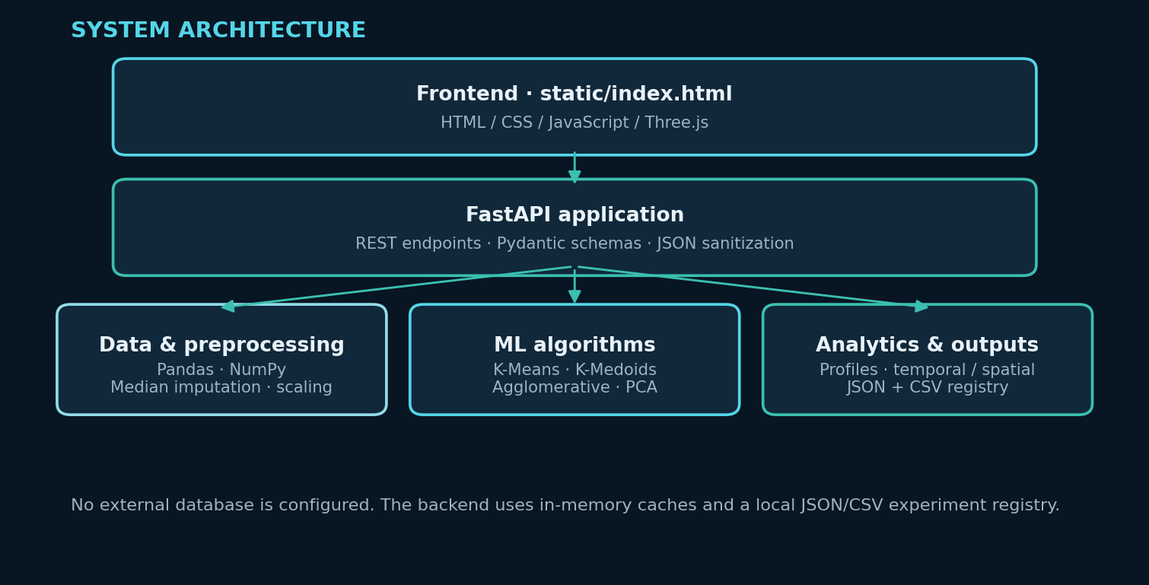
Figure 5. Current application architecture.
Layer | Technology / implementation
Frontend | Static HTML, CSS, JavaScript, Tailwind CSS, Three.js
Backend API | Python, FastAPI, Uvicorn, Pydantic
Data handling | Pandas, NumPy
Machine learning | Scikit-learn, SciPy
Visualization | Three.js for 3D scenes; backend PCA and dendrogram data; HTML interface charts and summaries
Experiment storage | Local JSON and CSV registry under outputs/
Database | No external relational database configured; data and experiment results are handled through CSV files, in-memory caches, JSON and CSV outputs

RESTful API Endpoints
Endpoint | Purpose
GET /api/health | Backend health and cache status
GET /api/dataset/summary | Dataset dimensions, missingness, dates, locations, rainfall summary
GET /api/dataset/features | Column and feature metadata
POST /api/preprocessing/configure | Configure preprocessing and observation mode
POST /api/clustering/kmeans | Run a custom K-Means model
GET /api/clustering/kmeans/evaluate | Evaluate K-Means across a K range
GET /api/clustering/kmeans/stability | Run K-Means multi-seed stability evaluation
POST /api/clustering/kmedoids | Run Manhattan medoid-based clustering
POST /api/clustering/hierarchical | Run agglomerative clustering
GET /api/clustering/hierarchical/compare_linkages | Compare five linkage/distance configurations
GET /api/results/metrics, /profiles, /pca | Retrieve current model metrics, profiles, and PCA output
GET /api/results/dendrogram, /geography, /temporal | Retrieve dendrogram, location, and temporal analysis
GET /api/experiments | Retrieve experiment registry

6. Clustering Algorithms & Models

6.1 K-Means Partitioning (Euclidean Distance)
K-Means minimizes the Within-Cluster Sum of Squares (WCSS / Inertia) using iterative centroid updates based on Euclidean geometry. Model evaluation spans K = 2 through 8 using k-means++ initialization. The algorithm efficiently scales across the complete 145,460-row dataset.

6.2 Manhattan Medoid Partitioning (CLARA Variant)
To offer robust distance metric options, a medoid-based algorithm utilizing Manhattan (L1 / cityblock) distance is implemented. Operating on data sub-samples in a CLARA-style architecture, it selects exemplar medoid observations to mitigate outlier influence. Total Manhattan cost (Sum of Absolute Deviations) is estimated via batch sampling.

6.3 Agglomerative Hierarchical Clustering
Agglomerative clustering evaluates hierarchical relationships without requiring predefined cluster counts. Five linkage/metric configurations are evaluated: Ward (Euclidean), Complete (Euclidean, Manhattan), and Average (Euclidean, Manhattan). Tree structures and cophenetic correlation coefficients are derived from a stratified multi-station sample [4].

6.4 Principal Component Analysis (PCA)
PCA projects the 11-dimensional feature matrix onto orthogonal axes, enabling visual inspection of cluster separability in 2D and 3D coordinate space. Cluster assignments computed in full feature space are overlaid onto the lower-dimensional projection.

7. Results & Model Evaluation: K-Means
Model evaluation runs were executed with random_state=42, n_init=3, and max_iter=100. WCSS is measured across all observations, while Silhouette Scores and Davies–Bouldin Indices are computed on a uniform random validation sample of n = 2,000 [3].
K | WCSS (full data) | Silhouette (n=2,000) | DBI (n=2,000) | Balance ratio
2 | 1,169,947.49 | 0.2382 | 1.5388 | 0.8450
3 | 1,013,075.39 | 0.2191 | 1.6617 | 0.5480
4 | 911,967.32 | 0.1608 | 1.6767 | 0.4972
5 | 842,633.31 | 0.1533 | 1.6167 | 0.4751
6 | 786,568.01 | 0.1589 | 1.6090 | 0.4223
7 | 746,109.46 | 0.1539 | 1.5856 | 0.3464
8 | 715,044.58 | 0.1428 | 1.6194 | 0.4360

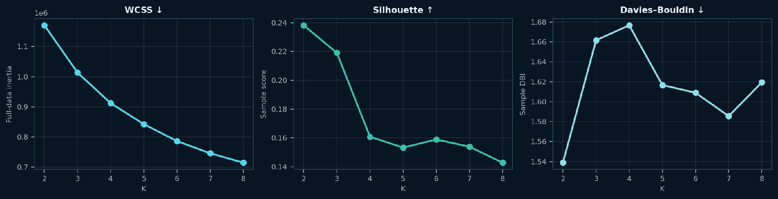
Figure 6. K-Means WCSS, Silhouette, and Davies–Bouldin comparison for K=2..8.
Evaluation Analysis: K = 2 achieves peak cluster separation (Silhouette 0.2382, DBI 1.5388). K = 4 (Silhouette 0.1608, DBI 1.6767) provides higher operational utility by resolving distinct meteorological profiles (e.g., dry-warm, cool-wet, humid-tropical) necessary for atmospheric analysis.

8. Algorithm Comparison: Medoid & Hierarchical Models

Manhattan Medoid Partitioning (K = 4)
The Manhattan medoid baseline (K = 4) yielded a Sum of Absolute Deviations (SAD) of 943,105.69 and a Manhattan Silhouette Score of 0.1307. Euclidean diagnostic indices are provided for cross-model reference.
Method (K=4) | Objective / cost | Silhouette | DBI (Euclidean diagnostic) | Balance
K-Means / Euclidean | WCSS 911,967.32 | 0.1587 | 1.6881 | 0.4972
K-Medoids / Manhattan | SAD 943,105.69 | 0.1307 | 2.1062 | 0.4871

WCSS (L2) and SAD (L1) represent fundamentally distinct distance metrics and are not directly comparable in absolute magnitude.

Hierarchical Linkage Comparison (K = 4)
Configuration | Silhouette | DBI* | Cophenetic corr. | Balance ratio
Ward (Euclidean) | 0.1445 | 1.9743 | 0.4373 | 0.6652
Complete (Euclidean) | 0.1100 | 1.8685 | 0.4289 | 0.0565
Complete (Manhattan (Cityblock)) | 0.1270 | 1.9159 | 0.4365 | 0.2075
Average (Euclidean) | 0.2019 | 0.8219 | 0.5614 | 0.0007
Average (Manhattan (Cityblock)) | 0.1831 | 1.1506 | 0.5580 | 0.0027

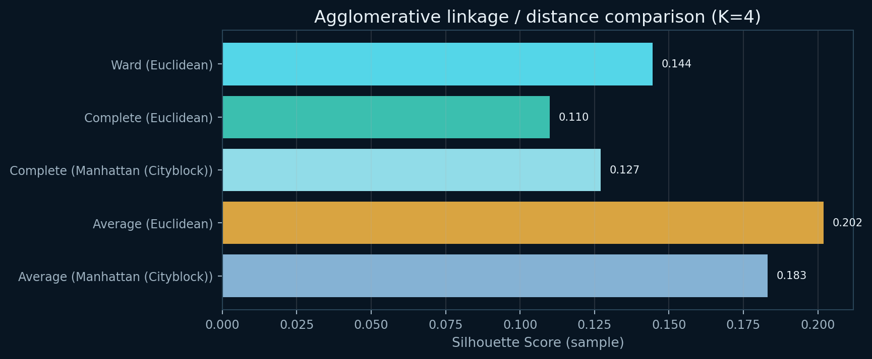
Figure 8. Silhouette scores for the five hierarchical configurations.
Hierarchical evaluations were executed on a stratified sample of 1,493 observations. Average linkage achieves higher Silhouette scores (0.2019) but creates severely imbalanced partitions (balance ratio 0.0007), rendering Ward linkage (Silhouette 0.1445, balance ratio 0.6652) the preferred hierarchical configuration for structural stability.
*Davies–Bouldin values for Manhattan linkage models utilize standard Euclidean diagnostic computations to facilitate direct structural comparison against K-Means baselines.

9. PCA & Empirical Cluster Profiling
Principal Component Analysis captures 74.97% of total variance across the top three components: PC1 (41.27%), PC2 (20.17%), and PC3 (13.53%). This confirms that low-dimensional projections preserve the primary variance structure of the full feature matrix.
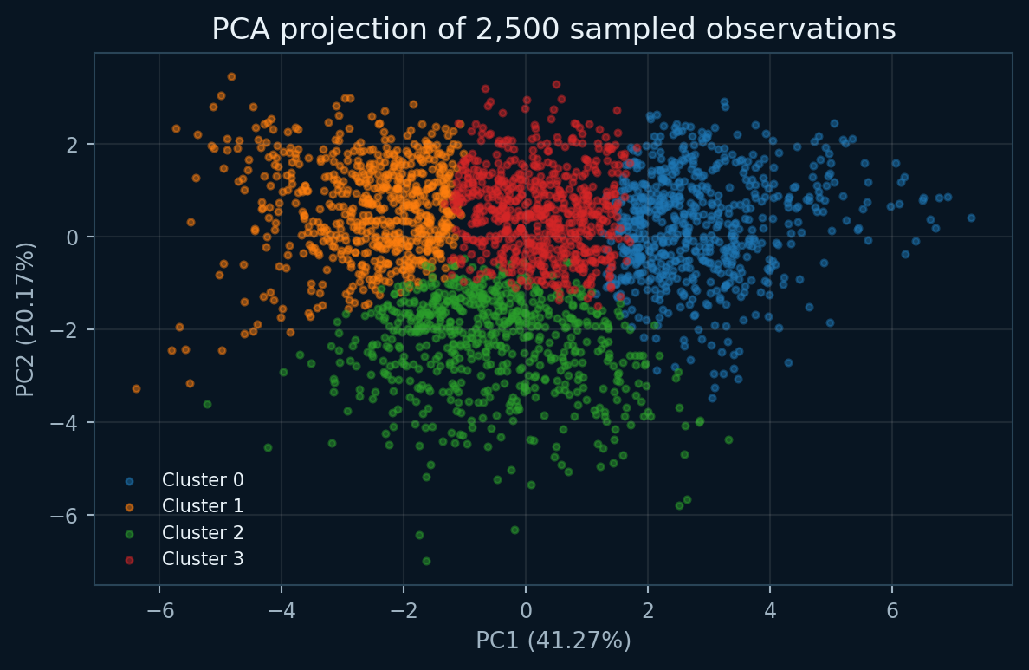
Figure 9. PCA view of sampled observations coloured by the K=4 baseline cluster assignment.
Component | Explained variance | Interpretation in application
PC1 | 41.27% | Largest direction of variation; inspect actual loadings before assigning a physical label.
PC2 | 20.17% | Second orthogonal direction; inspect actual loadings before assigning a physical label.
PC3 | 13.53% | Third orthogonal direction; inspect actual loadings before assigning a physical label.
PC1 + PC2 + PC3 | 74.97% | Combined variance retained in the 3D representation.

Empirical Profiles for Baseline K = 4 Clusters
Cluster | n | Share | Mean rain mm/day | Rain >1 mm | Humidity 3pm | Temp 3pm
Cluster 0 | 32,633 | 22.43% | 0.66 | 9.3% | 37.7% | 30.8°C
Cluster 1 | 36,304 | 24.96% | 0.95 | 18.9% | 58.3% | 15.3°C
Cluster 2 | 25,412 | 17.47% | 10.71 | 76.6% | 70.0% | 17.6°C
Cluster 3 | 51,111 | 35.14% | 0.23 | 5.9% | 46.2% | 22.5°C

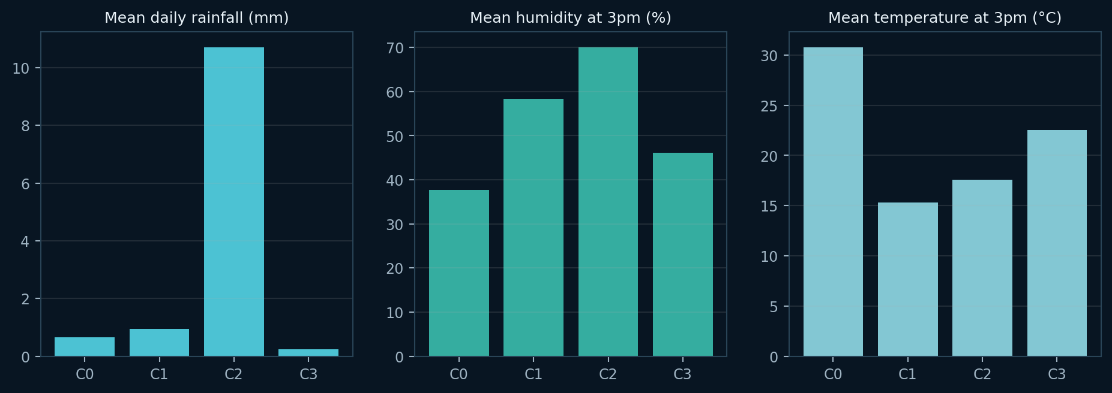
Figure 10. Selected empirical cluster profile variables for the K=4 baseline.
Clusters exhibit clear meteorological segregation: Cluster 2 captures wet, high-humidity synoptic conditions (mean rainfall 10.71 mm/day, 76.6% rainy days), whereas Cluster 3 reflects warm, semi-arid states (mean rainfall 0.23 mm/day, 5.9% rainy days).

10. Spatial & Temporal Analysis

Geographic Distribution
Geographic mapping links cluster proportions to spatial coordinates across 49 observation locations. Regional variations highlight regional atmospheric regimes, such as coastal wet belts versus interior arid zones.

Temporal & Seasonal Patterns
Seasonal aggregations follow Southern Hemisphere definitions (Summer: Dec–Feb, Autumn: Mar–May, Winter: Jun–Aug, Spring: Sep–Nov). State transition matrices analyze consecutive daily transitions per location, isolating multi-day weather persistence from seasonal regime shifts.

11. Testing, Verification & Security

Automated Test Suite Results
System reliability was verified using pytest. All 10 automated test modules passed successfully (runtime 31.28s), covering data ingestion, preprocessing transformation pipelines, partition clustering, hierarchical tree generation, PCA projections, and REST API routing.

Figure 11. Rainfall Atlas landing interface screenshot.
Test area | Coverage
Data and preprocessing | CSV loading, summary fields, imputation/scaling pipeline
Partition algorithms | K-Means, stability routine, Manhattan medoid routine
Hierarchical | Agglomerative output and dendrogram structure
Dimensionality reduction | PCA output and variance metadata
Interpretation services | Profiles, geographic summaries, temporal distributions
API | Health, dataset, model results, PCA, dendrogram, geography, temporal, comparison endpoints

Deployment & Cloud Infrastructure
The backend API is hosted on Render and served locally via Uvicorn on port 8000. Analytical caches warm during application startup to optimize response latencies across frontend data requests.

Security & Production Considerations
As an exploratory platform, the service does not enforce user authentication. Production deployments should restrict current wildcard CORS settings, implement rate limiting, introduce API key authentication, and establish encrypted transport layers.

Practical Applications & Societal Value
The platform offers significant utility for academic research, regional climate data exploration, and unsupervised learning pedagogy. It provides objective data stratification to complement formal meteorological modeling.

12. Limitations & Future Work

Current System Limitations
- The dataset covers Australian locations only and should not be generalized to all climate regions.
- Weather observations are uneven across locations and variables. Missingness and station representation can influence distance-based clusters.
- The primary observation unit is a daily weather observation. The resulting groups are best treated as weather-state clusters unless persistence over longer time scales is independently demonstrated.
- K-Means scores show that K=2 is better by Silhouette and Davies-Bouldin in the tested K range. The current K=4 baseline is an exploratory higher-resolution choice, not a proven mathematical optimum.
- K-Means stability is high across the tested seeds, but stable partitions can still be weakly separated or sensitive to feature design.
- The Manhattan medoid routine is sampled and CLARA-style; its current implementation is not a canonical PAM swap-search implementation, and its total cost is estimated.
- Hierarchical clustering is performed on a stratified sample, not the entire dataset. The requested sample size of 1,500 yielded 1,493 observations in the executed run because of per-location rounding. Approximate full-data labels are produced by nearest sample-centroid assignment and must be distinguished from exact hierarchical labels.
- The standard Davies-Bouldin index is Euclidean; for Manhattan variants it is a supplementary Euclidean diagnostic, not a native Manhattan DBI.
- The monthly mode currently averages selected numerical variables by location-month. It does not yet implement a full monthly rainfall feature set such as total rainfall and wet-day frequency.
- The correlation matrix is computed, but correlated variables are not automatically removed or reweighted.
- Some 3D scenes are illustrative or procedural. They should not all be interpreted as direct renderings of model-computed geometry.
- The location coordinate lookup is embedded in code rather than provided by the CSV; station-level coordinate provenance should be verified.
- A hosted application URL has been supplied by the project team, but its availability must be verified immediately before submission. The application does not implement authentication or user-role management. The CORS configuration includes a wildcard origin, which should be restricted for production. Do not use the public demonstration with sensitive data. Production hardening should include access controls, request limits, secure configuration, monitoring, and logging.

Future Scope & Enhancements
- Implement a robust location-month or location-season regime definition using monthly rainfall totals, wet-day frequency, maximum rainfall, and variability.
- Replace the current medoid refinement with a verified PAM implementation or a documented CLARA implementation with consistent candidate evaluation.
- Retain exact hierarchical sample IDs and report realized sample sizes; keep approximate full-data extension separate in every output.
- Use common evaluation samples for metrics across models and record metric geometry explicitly.
- Conduct sensitivity analysis on feature weights, correlation handling, rainfall transformations, and alternative observation units.
- Validate cluster profiles with meteorological literature or independent domain evidence before using named climatological regimes.
- Verify station coordinates against the Bureau of Meteorology station directory and document mapping provenance.
- Improve production security, authentication, logging, asynchronous job handling, and deployment configuration.

Responsible Use Statement
Discovered clusters represent statistical groupings within historical feature space. They do not constitute official weather warnings, hazard assessments, or predictive forecasts.

13. Individual Contributions
The table below summarizes individual project responsibilities and completed deliverables across the project team.
Member name | Registration number | Individual contribution (specific completed work)
[Member 1 full name] | [Registration number] | [Describe actual completed tasks and evidence]
[Member 2 full name] | [Registration number] | [Describe actual completed tasks and evidence]
[Member 3 full name] | [Registration number] | [Describe actual completed tasks and evidence]
[Member 4 full name] | [Registration number] | [Describe actual completed tasks and evidence]

Declaration of Authorship
We declare that the work presented in this report is original and carried out in accordance with academic integrity guidelines.

14. References & Data Sources
[1] Kaggle. Rain in Australia (weatherAUS.csv) dataset. https://www.kaggle.com/datasets/jsphyg/weather-dataset-rattle-package (accessed Nov 3, 2026).
[2] Australian Bureau of Meteorology. About Weather Station Data. https://www.bom.gov.au/climate/cdo/about/about-weather-data.shtml (accessed Nov 3, 2026).
[3] Scikit-learn Developers. sklearn.metrics.silhouette_score. https://scikit-learn.org/stable/modules/generated/sklearn.metrics.silhouette_score.html (accessed Nov 3, 2026).
[4] SciPy Developers. Hierarchical Clustering (scipy.cluster.hierarchy). https://docs.scipy.org/doc/scipy/reference/cluster.hierarchy.html (accessed Nov 3, 2026).
[5] MacQueen, J. (1967). Some methods for classification and analysis of multivariate observations. Proc. 5th Berkeley Symp. Math. Statist. Prob., 1, 281–297.
[6] Davies, D. L., & Bouldin, D. W. (1979). A cluster separation measure. IEEE Trans. Pattern Anal. Mach. Intell., 1(2), 224–227.
[7] Rousseeuw, P. J. (1987). Silhouettes: A graphical aid to the interpretation and validation of cluster analysis. J. Comput. Appl. Math., 20, 53–65.

